SELECT Railing System
Specification Sheet
MR-MANUFACTURER
MFR Manufacturing Corp, Inc.offers technical assistance to Architects, Engineers, Contractors, Owners and Facility Managers regarding the design and installation of our products. We have provided many custom solutions for unusual situations. Let our experienced engineers assist you in determining the optimum design for your project. Please contact MFR Manufacturing Corp, Inc.,at 815-552-3333 to obtain our services. You also can contact us by e-mail at info@mfrcorp.com or visit our Website at www.mfrcorp.com for additional information.
MFR Manufacturing Corp, Inc.
1065 Sill Ave
Aurora, IL 60506
TEL: 815-552-3333, FAX 815-552-3315
PP-PRODUCT PRESENTATION
The SELECT system utilizes the strength and flexibility of the SELECT panels from MFR Manufacturing Corp, Inc.. The SELECT System enables us to offer an affordable modular system, which is practical, durable and sturdy. This unique railing system provides a wide variety of design solutions. It can be brightly colored and configured to be a design feature or it can blend inconspicuously with the surroundings.
The SELECT panels are ideally suited for retrofitting existing railing systems, which are not in compliance with current building codes.
SELECT Railing System is based on MFR’s infill panels. These panels are available as perforated, extruded and woven mesh panels.
Railing System
The SELECT Railing System can span between post supports or be mounted onto structurally suitable elements. An average post spacing of 3’-6” to 4’-0” for stairs and 3’-6” to 4’-6” for straight balcony railings is recommended. The system can span up to 12’ if optional available horizontal supports are used. See our CAD details for additional information. Please contact MFR Manufacturing Corp, Inc. for engineering and design assistance when preparing detail solutions.
Handrails
For railing types we offer optional these handrail types: Channel, square and rectangular tubes. Handrails may be finished to match or contrast with the supports and panels. Wood and other handrail materials can also be specified and supplied by MFR.

SELECT Panel Types
The MFR panel styles listed below are available.

SELECT “P”
Characteristics:
Perforated metal panels. Available in different perforation styles and sizes. Available in Aluminum, Steel and Stainless Steel.

Specify:
Specifier please indicate:
Railing System style SELECT “P”, frame materials [aluminum] [steel] [stainless steel]. Panel material [aluminum] [steel] [stainless steel].Pattern as per sketch [insert sketch from selection below], Pattern and hole sizes and spacing as per sketch below [insert hole spacing and hole size in sketch chosen from below].

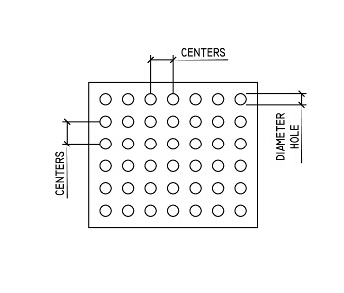 | 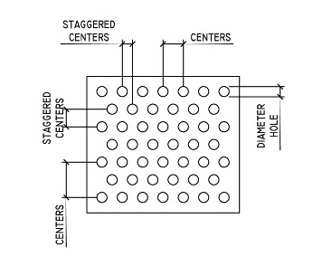 | 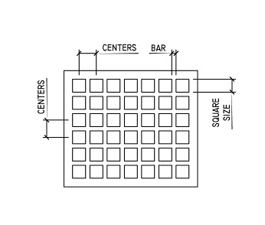
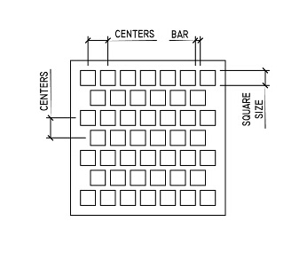 | 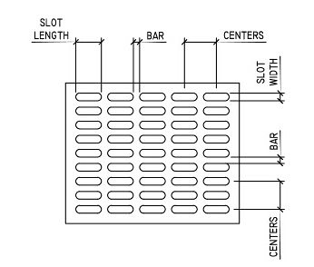 | 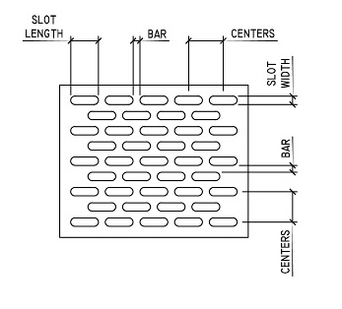
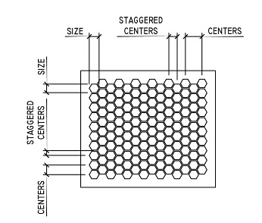 | 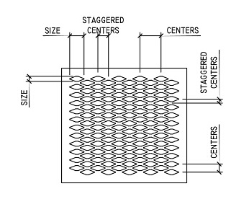 | 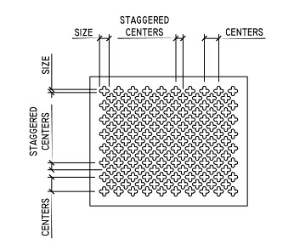
 | 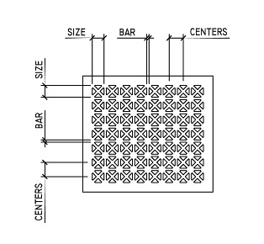

SELECT “W”
Characteristics:
Woven Wire Mesh Panels. Available in different perforation styles and sizes. Available in Steel and Stainless Steel.

Specify:
Specifier please indicate:
Railing System style SELECT “W”, frame materials [aluminum] [steel] [stainless steel]. Panel material [steel] [stainless steel].Pattern as per sketch [insert sketch from selection below], Pattern and hole sizes and spacing as per sketch below [insert hole spacing and hole size in sketch chosen from below].

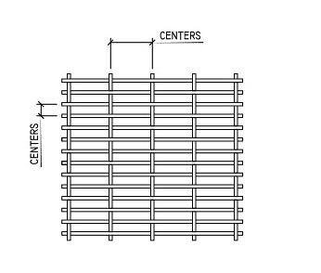 | 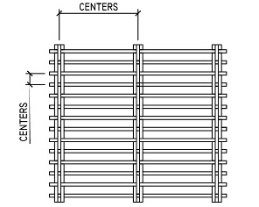 | 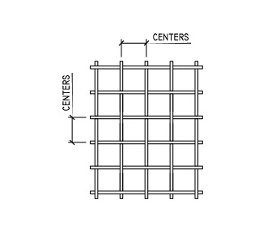
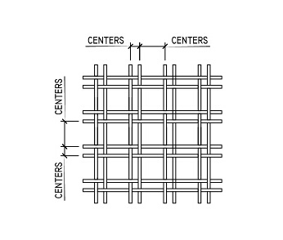 | 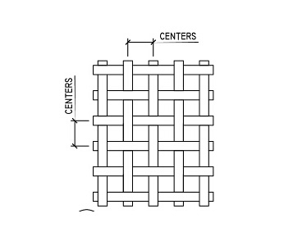

SELECT “E”
Characteristics:
Perforated metal panels. Available in different perforation styles and sizes. Available in Aluminum, Steel and Stainless Steel.

Specify:
Specifier please indicate:
Railing System style SELECT “E”, frame materials [aluminum] [steel] [stainless steel]. Panel material [aluminum] [steel] [stainless steel].Pattern as per sketch [insert sketch from selection below], Pattern and pattern slot sizes and spacing as per sketch below [insert hole spacing and hole size in sketch chosen from below].

Curved Railings
All SELECT panels are available in a curved design. The minimal radius that can be rolled is 4’-0”.
AI-ASSEMBLY, INSTALLATION
Posts can be attached to the structure below in several ways:
Using the recessed method, posts are set into cored holes or sleeves and anchored with non-shrink grout.
Using the surface mount method, mounting plates attached to each post are expansion bolted to the structure below.
Using the face mount method, the railing posts are mounted to the face of the structure typically below the level of the walking surface.
MF-MATERIALS, FINISHES
Thermosetting Polyester Powder Finish
MFR Manufacturing Corp, Inc.Fence and Railing Panels are protected by what we believe are the best finishes available today.
Hardness ASTM D3363: 2H
Direct Impact ASTM D2794: 160 in/lbs
Weatherability ASTM D822: 89%

Colors
8 Standard Colors are available: White, Black, Blue, Green, Red, Yellow, Gray and Brown. Additional we offer an almost unlimited selection of custom colors. The polyester powder coating is available for all our products.
20-Year Warranty
MFR Manufacturing Corp, Inc. certifies that its Products are free from defects in material and workmanship. The hot-dip galvanized coating (if applied) can leave minor impurities on the treated surface, i.e., flashing, drips, drops, etc. These do not impair the coating in terms of corrosion resistance. The polyester-coated and galvanized metal is guaranteed not to rust for a period of 20 years. Accidental damages, defects resulting from improper installation and damage from vandalism or abuse are not included. Warranty is limited to a prorated value of the coating, not to exceed the original value of the coating.

